20) Write a C program to implement Heap sort

PROGRAM:

#include <stdio.h>

void heapify(int arr[], int n, int i) {

int largest = i;

int left = 2 \* i + 1;

int right = 2 \* i + 2;

if (left < n && arr[left] > arr[largest])

largest = left;

if (right < n && arr[right] > arr[largest])

largest = right;

if (largest != i) {

int temp = arr[i];

arr[i] = arr[largest];

arr[largest] = temp;

heapify(arr, n, largest);

}

}

void heapSort(int arr[], int n) {

for (int i = n / 2 - 1; i >= 0; i--)

heapify(arr, n, i);

for (int i = n - 1; i > 0; i--) {

int temp = arr[0];

arr[0] = arr[i];

arr[i] = temp;

heapify(arr, i, 0);

}

}

void printArray(int arr[], int n) {

for (int i = 0; i < n; ++i)

printf("%d ", arr[i]);

printf("\n");

}

int main() {

int arr[] = {12, 11, 13, 5, 6, 7};

int n = sizeof(arr) / sizeof(arr[0]);

printf("Original array: \n");

printArray(arr, n);

heapSort(arr, n);

printf("Sorted array: \n");

printArray(arr, n);

return 0;

}

INPUT:

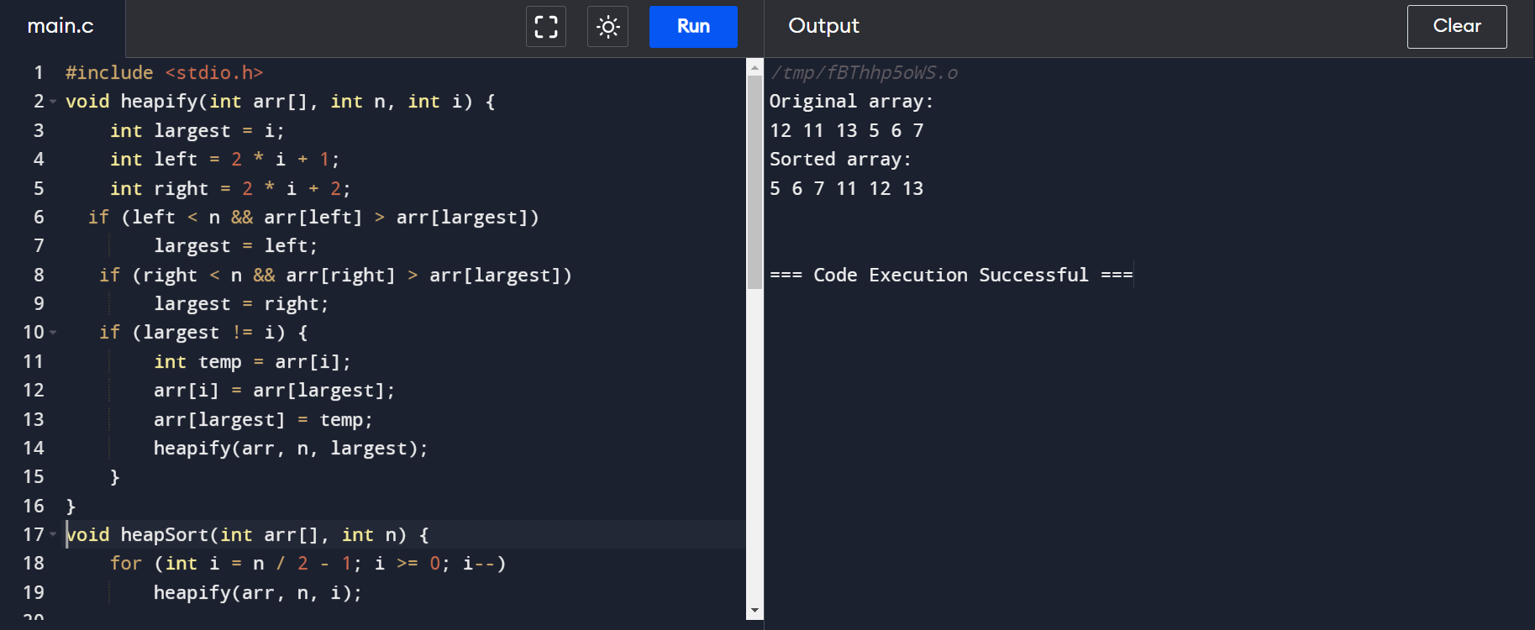

OUTPUT:

